experiment: Hydrostatic Pressure
*********Watch the experiment in the video and write down in the below Table 1 the data collected at the end of the video and proceed with finishing this report*********
Driving Question | Objective
How is static pressure related to depth in a column of water? Experimentally determine the mathematical relationship between static pressure and depth in a column of water.
Materials and Equipment
- Data collection system | - Water reservoir, transparent, over 40 cm high
- PASCO Wireless Pressure Sensor1 | - Ruler
- Luer lock connector1 | - Distilled water, to fill the reservoir
- Tubing, 1/8" inner diameter, 50-cm1

PASCO Wireless Pressure Sensor
Background
Anyone who has tried to swim to the bottom of a deep swimming pool has experienced the sensation of pressure on their body. The deeper you swim, the greater the pressure. So if you swim to twice the depth, would you feel twice the pressure? What is the mathematical relationship between the pressure on your body and the depth in the pool?
In this activity, you will measure the pressure at different depths using a pressure sensor to determine a mathematical relationship between pressure and depth.
Safety
Follow this important safety precaution in addition to your regular classroom procedures:
- Make necessary arrangements to your workstation to avoid getting water on any electronic equipment.
Procedure
Set Up
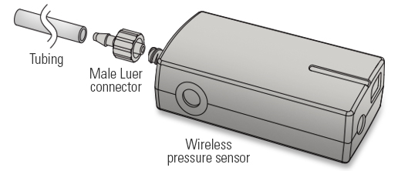
1. Cut a length of plastic tubing approximately as long as the water reservoir is deep and connect the tubing to the valve on the pressure sensor using the barbed Luer connector.
2. Connect the pressure sensor to the data collection system, and then configure the data collection system to monitor data in
a digits display.
3. Fill the water reservoir approximately 3/4 full with distilled water.
Collect Data
4. Hold the pressure sensor and the attached tubing above the water level in the reservoir, and then record the first pressure measurement and corresponding depth (0 cm) in Table 1.
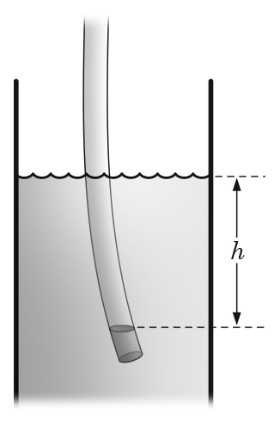
5. Submerge the open end of the tubing from the pressure sensor into the water, lowering the tubing end to a depth of 4 cm.
NOTE: The tubing may not be straight, which is not a problem as long as the depth is measured at the point of the open end of the tubing.
6. Record the pressure P and depth h in Table 1.
NOTE: At greater depths, a small volume of water may creep up the tubing as the air inside the tubing compresses. In this case, measure the depth h from the surface of the water to the water level inside the tubing.
7. Lower the tube into the water four additional centimeters.
8. Repeat the previous steps until you have recorded the pressure at six depths: 0 cm, 4 cm, 8 cm, 12 cm, 16 cm, and 20 cm.
9. Empty your water reservoir.
Data Analysis
Table 1: Pressure versus depth in a water column
Depth  (cm) | Pressure  (kPa)
0 | 100.3
4 | 100.7
8 | 101.0
12 | 101.5
16 | 101.8
20 | 102.2
1. Plot a graph of pressure versus depth in the blank Graph 1 axes. Be sure to label both axes with the correct scale and units.

Graph 1: Pressure versus depth in a water column
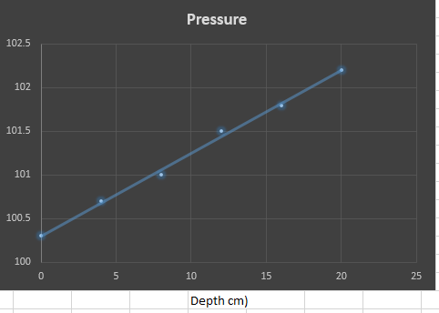

2. Draw a line of best fit through your data in Graph 1. Determine and record the equation of the line here:
Best fit line equation: | Y = 0.075 x + c
Analysis Questions
- 1. Does a graph of pressure versus depth produce a linear relationship? If yes, what is the y-intercept of the relationship equal to (theoretically)? Y intercept = -3.5525
- 2. Static pressure is related to depth according to the equation,
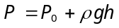
where P is pressure, P0 is the initial pressure, ρ is fluid density, g is acceleration due to gravity, and h is depth. From a linear graph relating pressure to depth, extrapolate a value for the density of the fluid in the reservoir (water). Show your work.
P= 100.7 kpa
P_{o} = 100.3 kpa
G= 9.81m/s
H= 0.04
100.3 + p*9.81*0.04= 0.3924p + 100.3
100.7-100.3= 0.4
0.4/0,3924= 981 kg/m³

- 3. If the theoretical value of the density of water is 1,000 kg/m3, calculate the percent error between your experimental value and the actual value. Show your work.
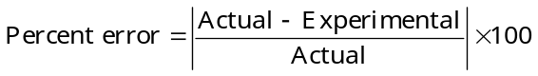
% error = 1000-981/1000* 100= 1.9 %
- 4. If you performed this same experiment using liquid iodine (density ≈ 4,900 kg/m3) instead of water, how would a graph of pressure versus depth be different?
The pressure in this case would be higher compared to that of water thus changing the y intercept and the gradient of the graph.
Synthesis Questions
- 1. Imagine you are submerged in a submarine 1,066 m below the surface of the ocean. On this submarine is a round window made of glass. How thick would the glass need to be if 4 mm of glass is needed per 197.5 kPa pressure difference to prevent the glass from shattering? Assume ocean water has a density of 1,030 kg/m3, and that the pressure inside the submarine is equal to atmospheric pressure.
P= 100.3 + 1030*9.81*1066
P= 10771184.1
10771184.1/1000= 10771.184 * 4/197.5= 218 mm
- 2. A group of marine biologist researchers have found a rare form of sea life that exists only at great depth in the ocean. If these researchers measured the gauge pressure at the depth these creatures live and found it to be 377 atm, at what depth in meters do these creatures live? Assume ocean water has a density of 1,030 kg/m3.
1atm = 101 kpa
377 atm= 38199.5 kpa
38199.5= 100.3 + 1030*9.81h
38099.2=10104.3h
38099.2/10104.3 = 3.772*1000 = 3772 m

